Live recording of ”Downtown Alive! - Buckwheat Zydeco”

Event: Downtown Alive! - Buckwheat Zydeco
Venue: Parc International
Date: Nov 7, 2003
Time: 3:30 p.m. – 8:30 p.m. (recording 6:30 p.m. – 8:30 p.m.)
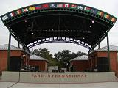

When I arrived at Parc International at 3:30 p.m., three engineers of Show and Tell Production were there. They already had carried out almost all their equipments.

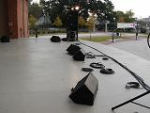

Monitor speakers and cables are placed roughly in place on the stage, but the microphones have not been set up yet. The engineers of Show and Tell Production are waiting for Jimmy Mouton, the sound engineer for Buckwheat Zydeco, to arrive.

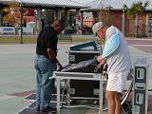

Jimmy Mouton has arrived. He is checking equipments of FOH, and an engineer of Show and Tell Production is connecting cables with the console of FOH.

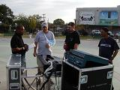

All engineers are gathering at FOH.
*And then I am going to connect our HD24 with the console of FOH.

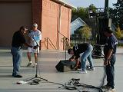

Engineers are setting up monitors and microphones. Jimmy Mouton instructs other engineers on the arrangement.

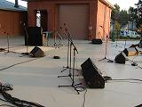

Because today’s band consists of drums, bass, two guitars, organ, accordion, rubboard and three horns, the monitor system is more complicated than usual.

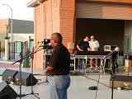

Jimmy Mouton checks each microphone and monitor. It takes long time to check all of them.

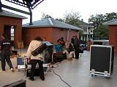

Some band members have arrived, and they are carrying out their instruments. Because it takes long time to set up drums, the drummer usually arrives first.

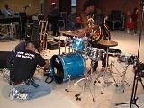

While the drummer is setting up his drum set, engineers are setting up microphones for drums. The drummer seems to be using two snare drums.

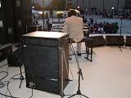

Buckwheat has arrived, and he is checking the sound of his Hammond organ. He uses a rotary speaker for his organ today.

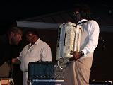

Buchwheat is checking the sound of his accordion with his engineer.

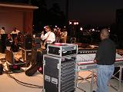

While each musician checks his own sound, Jimmy Mouton checks the sound of all instruments on the stage.

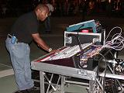

After setting up on stage, Jimmy Mouton has to work at FOH console. Many audience members already have come, and the show must be started soon.

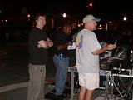

I ask Ivan to start HD24 because I will shoot a video. I appreciate his cooperation with us.

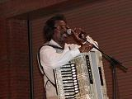

Downtown Alive has started, and Buckwheat starts to play.

Equipments

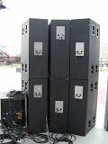
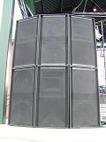

speakers (front) speakers (back)

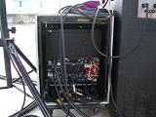
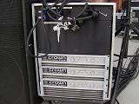

speaker amp (front) speaker amp (back)

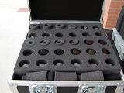
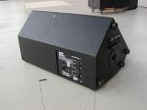

microphones monitor speaker

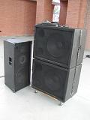
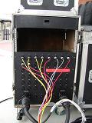

monitor speakers for drums splitter?

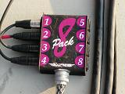
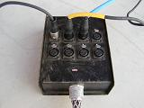

snake for microphones snake for monitors

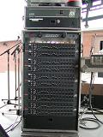

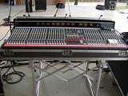

console for monitor equalizer for monitor

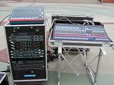
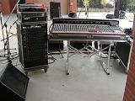

monitor booth front of house

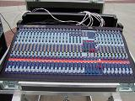
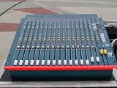

sub mixer for FOH console for FOH

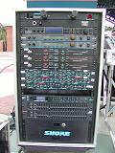

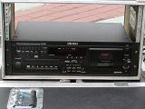

CD player and cassette deck effectors for FOH

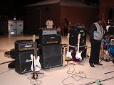
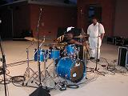

drum set and microphones guitar amps, bass amp and microphones

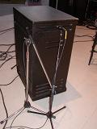
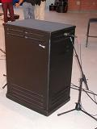

rotary speaker and microphones (right) rotary speaker and microphones (left)

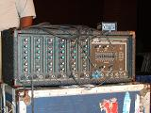

mixer amp for accordion

